Virtual Environment, Git, & SQLite
Virtual Environment
py -m venv venv\
This command creates a new virtual environment named venv using Python’s built-in venv module. The first venv that you use in the command specifies the module, and the second venv/ sets the name for your virtual environment. You could name it differently but calling it venv is a good practice for consistency.

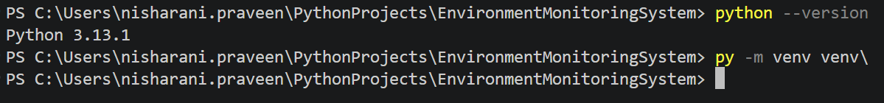

Your project now has its own virtual environment. Generally, before you start to use it, you’ll activate the environment by executing a script that comes with the installation:
venv\Scripts\activate

Before you run this command, make sure that you’re in the folder containing the virtual environment you just created. If you’ve named your virtual environment something other than venv, then you’ll have to use that name in the path instead of venv when you source the activation script.
Now create your requirements.txt file with the below text:
smbus2==0.6.0

Run the below command
python -m pip install -r requirements.txt
This command calls pip and tells it to install the dependencies in the requirements.txt file that you just created.
To deactivate virtual environment,
Type “deactivate”

Git (Assume git is already installed) – To be done by one team member
- Go to the folder “EnvironmentMonitoringSystem”
- Type “git init”
- Type “git status”
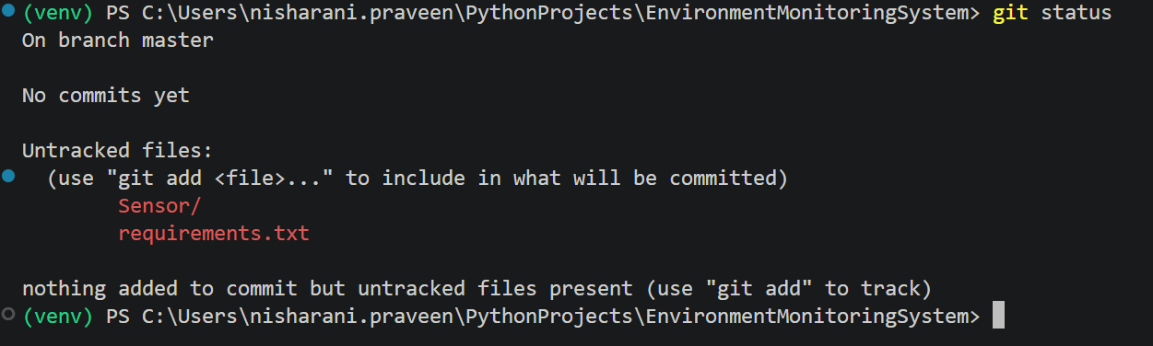
This will show you are in master/main branch
- Type “git add .”
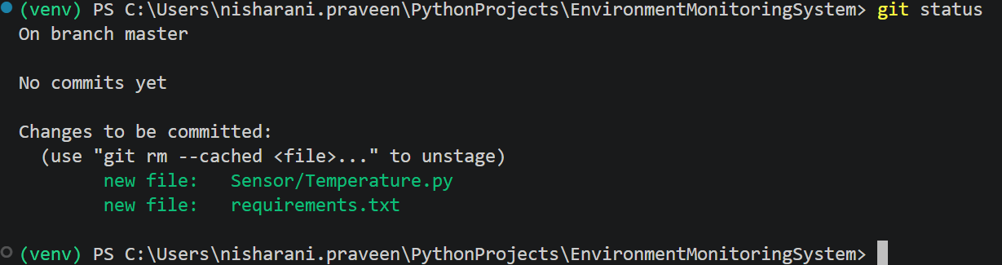
- Type “git commit -m “Initial commit”
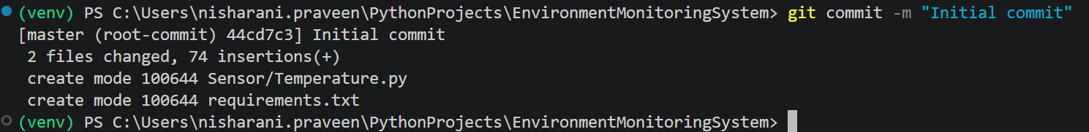
- Create a repo on GitHub with the name “Environment MonitoringSystem”
Go to: GitHub
- Click New repository
- Give it a name
- Do NOT initialize with README (important to avoid conflicts)
- Click Create repository

- Connect your local repo to GitHub
GitHub will show commands—use them, or run:

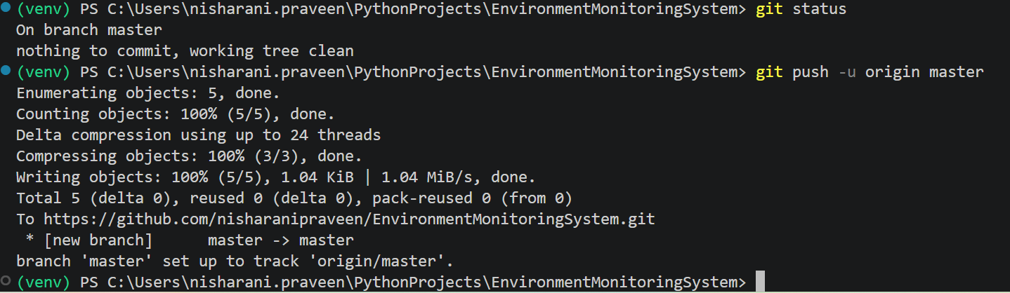

- (Team Members) Create a folder CLC. Open the folder CLC in VS Code.
- Ctrl + Shift + P
Select “Git: clone”
Copy the highlighted portion from your “Project Leader’s GitHub account” and paste it in your VS code
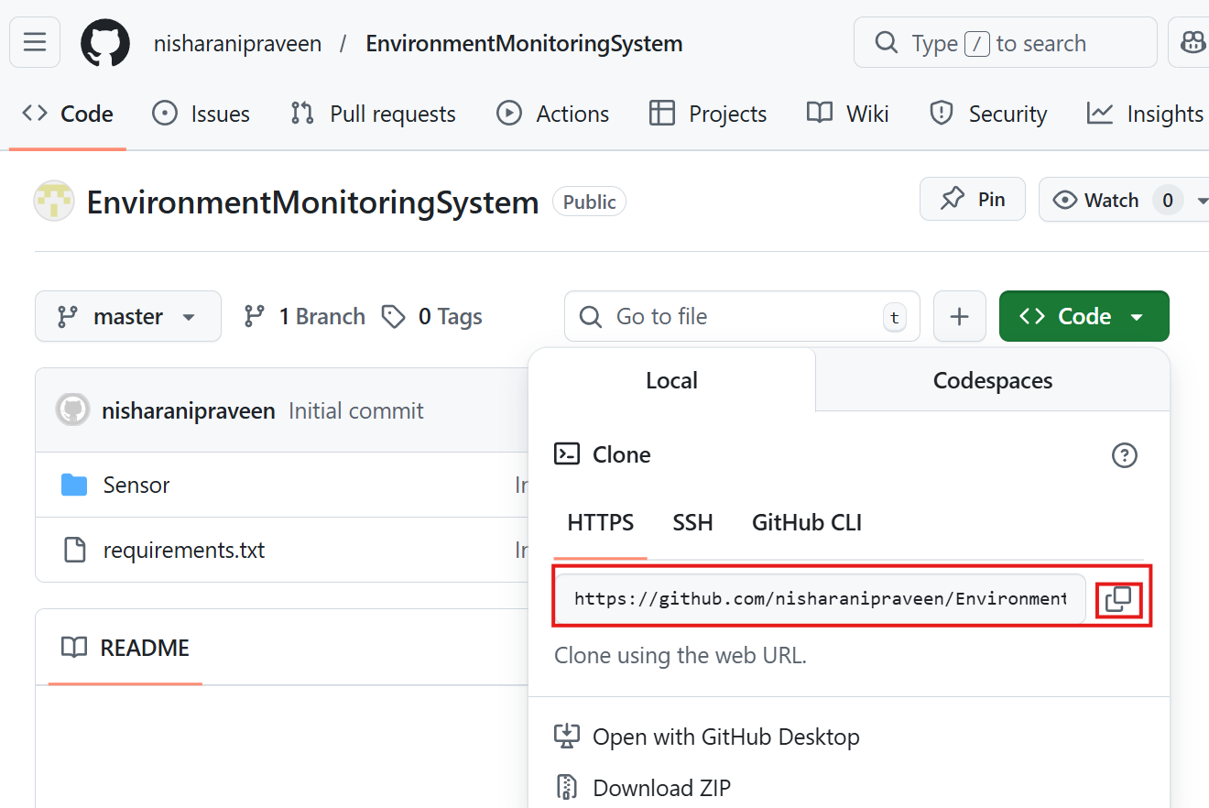

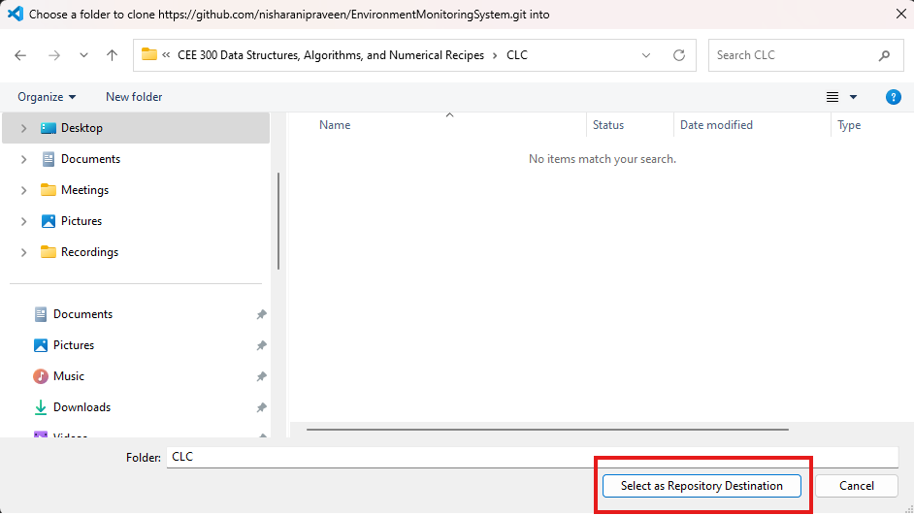
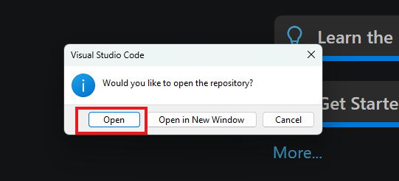

Ctrl+shift+P
Git: Checkout to …
Create new branch
Give the name “dev/<your name>”
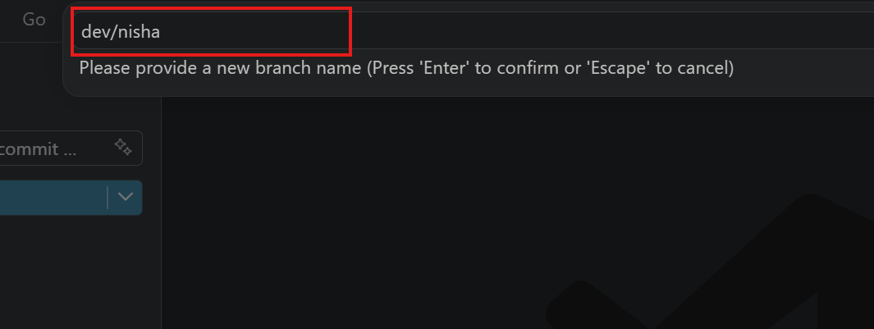

SQLite
Create a file “TemperatureDB.py “ inside “Sensor” folder.

Copy the below code into TemperatureDB.py
from Temperature import *
import sqlite3
from datetime import datetime

# 1. Connect to SQLite DB (creates file if not exists)
conn = sqlite3.connect("temperature.db")
cursor = conn.cursor()
# 2. Create table (only runs once)
cursor.execute("""
CREATE TABLE IF NOT EXISTS temperature_log (
id INTEGER PRIMARY KEY AUTOINCREMENT,
temperature REAL,
timestamp TEXT
)
""")
# 3. Function to insert data
def insert_temperature(temp):
timestamp = datetime.now().strftime("%Y-%m-%d %H:%M:%S")
cursor.execute(
"INSERT INTO temperature_log (temperature, timestamp) VALUES (?, ?)",
(temp, timestamp)
)
conn.commit()

# 4. Main loop (example)
for _ in range(5):
temp = read_temperature()
insert_temperature(temp)
print(f"Saved: {temp} at {datetime.now()}")
time.sleep(1)

# 5. Close connection
conn.close()

Do the below changes to the Temperature.py

# import smbus2 as smbus
import time

try:
import smbus # type: ignore
except ImportError:
class SMBus:
def __init__(self, bus): pass
def read_byte_data(self, addr, reg): return 0
def write_byte_data(self, addr, reg, value): pass

smbus = type('smbus', (), {'SMBus': SMBus})
The code we did in class today (3/31/2026) is available at
https://github.com/nisharanipraveen/EnvironmentMonitoringSystem.git

